

CSA05-DATABASE MANAGEMENT SYSTEMS

NAME: M DEVA SANDHYA
REG NO: 1921260074
COURSE CODE:
CSA0507
COURSE: DATABASE MANAGEMENT SYSTEM

AIM:
To Create, Alter, Drop, Rename, Truncate using Data Definition Language (DDL) statements. Description:
Data Definition Language (DDL) statements are used to define the database structure or schema. DDL Commands: Create, Alter, Drop, Rename, Truncate
- CREATE - to create objects in the database
- ALTER - alters the structure of the database
- DROP - delete objects from the database
- TRUNCATE - remove all records from a table, including all spaces allocated for the records are removed
- RENAME - rename an object

SYNTAX:
CREATE TABLE
CREATE TABLE table_name
(
column_name1 data_type, column_name2 data_type, column_name3 data_type,
....
);

ALTER A TABLE
To add a column in a table
ALTER TABLE table_name
ADD column_namedatatype;

To delete a column in a table
ALTER TABLE table_name
DROP COLUMN column_name;

DROP TABLE
DROP TABLE table_name;

TRUNCATE TABLE
TRUNCATE TABLE table_name;

Questions:
- Create a table name STUDENT with following structure.

# | Column Name | Description | Data Type
1 | RegNo | Registration Number | NUMBER(3)
2 | Name | Student Name | VARCHAR(15)
3 | Gender | Gender of the student | CHAR(1)
4 | DOB | Date of Birth | DATE
5 | MobileNo | Mobile Number | NUMBER(10)
6 | City | Location of stay | VARCHAR(15)

- Create a table name FACULTY with following structure.

# | Column  Name | Description | Data Type
1 | FacNo | Faculty Identifier | VARCHAR(4)
2 | FacName | Faculty Name | VARCHAR(15)
3 | Gender | Gender of faculty | CHAR(1)
4 | DOB | Date of Birth | DATE
5 | DOJ | Date of Join | DATE
6 | MobileNo | Mobile Number | NUMBER(10)

- Create a table name DEPARTMENT with following structure.

# | Column  Name | Description | Data Type
1 | DeptNo | Department Identifier | VARCHAR(4)
2 | DeptName | Department Name | VARCHAR(15)
3 | DeptHead | Department Head | VARCHAR(4)
- Create a table name COURSE with following structure.

# | Column  Name | Description | Data Type
1 | CourseNo | Course Identifier | VARCHAR(3)
2 | CourseDesc | Course  Description | VARCHAR(14)
3 | CourseType | Course Type | CHAR(1)
4 | SemNo | Semester Number | CHAR(1)
5 | HallNo | Hall Number | VARCHAR(4)
6 | FacNo | Faculty Identifier | VARCHAR(4)

- Modify the table FACULTY by adding a column name Dept of datatype VARCHAR(10)

OUTPUTS:
1)

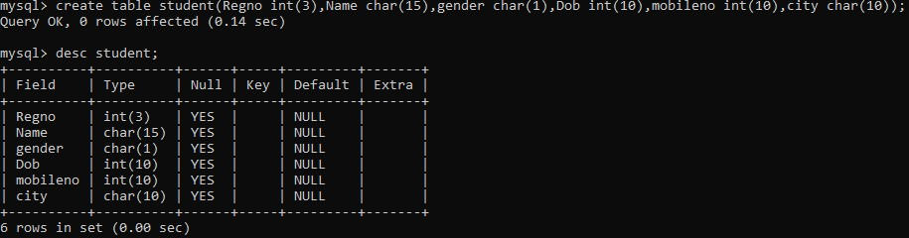
2)
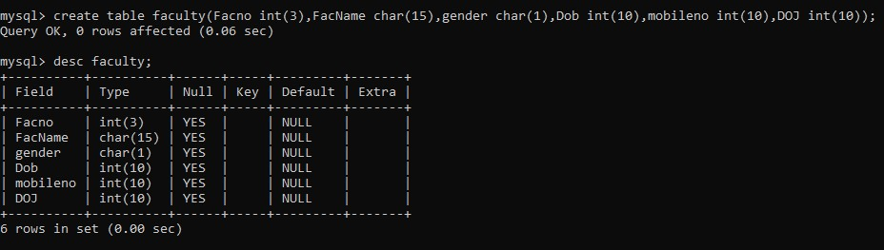
3)

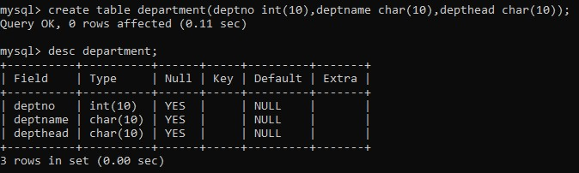
4)
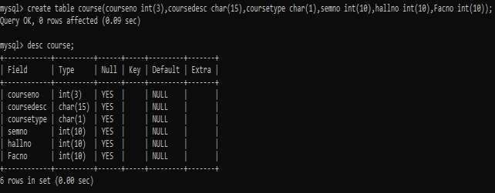

5)
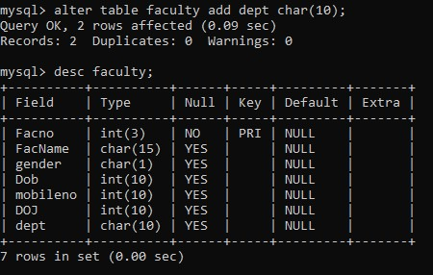

RESULT:
Tables are created, altered and modified using DDL commands.
DDL Commands with Constraints – PRIMARY, FOREIGN KEY, UNIQUE, CHECK AIM:
To add the constraints like primary key, foreign key, unique key and check using DDL commands.

Description:
PRIMARY KEY:
The PRIMARY KEY constraint uniquely identifies each record in a database table.
Primary keys must contain UNIQUE values, and cannot contain NULL values.
A table can have only one primary key, which may consist of single or multiple fields.

FOREIGN KEY:
- A FOREIGN KEY is a key used to link two tables together.
- A FOREIGN KEY is a field (or collection of fields) in one table that refers to the PRIMARY KEY in another table.
- The table containing the foreign key is called the child table, and the table containing the candidate key is called the referenced or parent table.
UNIQUE Constraint:
- The UNIQUE constraint ensures that all values in a column are different.
- Both the UNIQUE and PRIMARY KEY constraints provide a guarantee for uniqueness for a column or set of columns.
- A PRIMARY KEY constraint automatically has a UNIQUE constraint.
- However, you can have many UNIQUE constraints per table, but only one PRIMARY KEY constraint per table.
CHECK Constraint:
- The CHECK constraint is used to limit the value range that can be placed in a column
- If you define a CHECK constraint on a single column it allows only certain values for this column.
- If you define a CHECK constraint on a table it can limit the values in certain columns based on values in other columns in the row.

PRIMARY:
ALTER TABLE table_name
ADD PRIMARY KEY(primary_key_column);

FOREIGN KEY:
ALTER TABLE table_name
ADD CONSTRAINT constraint_name
FOREIGN KEY foreign_key_name (columns)
REFERENCES parent_table(columns)
ON DELETE action
ON UPDATE action

UNIQUE:
CREATE TABLE table_1(
...
column_name_1 data_type,
...
UNIQUE(column_name_1)
);

CHECK
CREATE TABLE IF NOT EXISTS parts ( part_no VARCHAR(18) PRIMARY KEY, description VARCHAR(40),
cost DECIMAL(10 , 2 ) NOT NULL CHECK(cost > 0), price DECIMAL (10,2) NOT
NULL
);
Questions:
- Alter the table STUDENT2 with following structure.

# | Column Name | Constraints
1 | RegNo | PRIMARY KEY

- Alter the table name FACULTY with following structure.

# | Column Name | Constraints
1 | FacNo | PRIMARY KEY
2 | Gender | CHECK ‘M’ or ‘F’

- Alter the table name DEPARTMENT with following structure.

# | Column Name | Constraints
1 | DeptNo | PRIMARY KEY

- Alter the table name COURSE with following structure.

# | Column Name | Constraints
1 | CourseNo | PRIMARY KEY
2 | SemNo | 1 to 6

- Alter the table name STUDENT2 with following structure.

# | Column Name | Constraints
1 | S1Name | UNIQUE KEY

- After the STUDENT2 & STUDENT3 tables are successfully created, test if you can add a constraint FOREIGN KEY to the RegNo of this table.
OUTPUTS:
1)

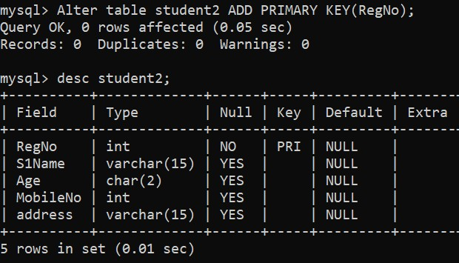

2)

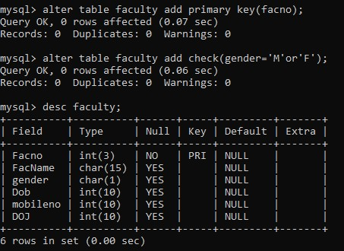
3)

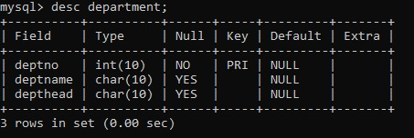
4)
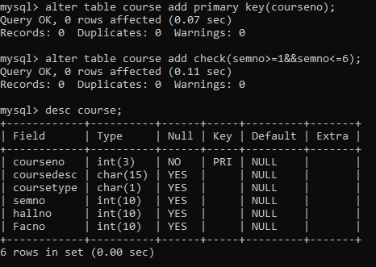
5)

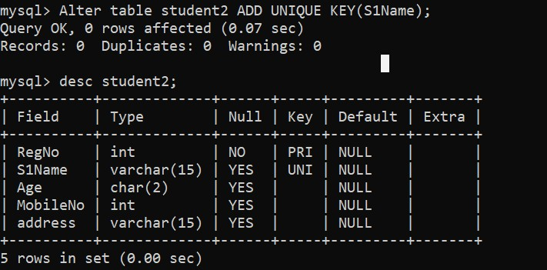
6 )

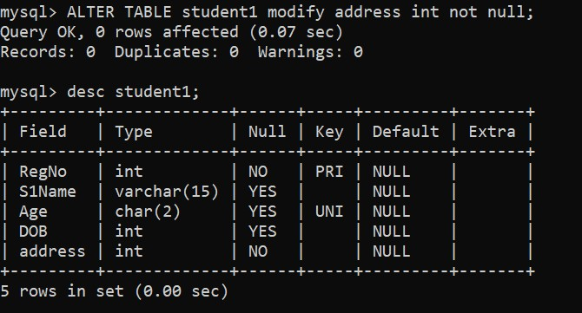

Result:
DDL Commands with Primary, Foreign, Unique, Check constraints are updated and verified.
Ex.No. : 3  Date: | DML Commands – INSERT, SELECT

Aim:
To perform Data Manipulation Language (DML) Commands such as INSERT, SELECT in the table.

Description:

Data Manipulation Language (DML) statements are used for managing data within schema objects. DML Commands: Insert, Select
- INSERT - insert data into a table
- SELECT - retrieve data from the a database

INSERT:
INSERT INTO table_name
VALUES (value1, value2, value3,...);
( or )
INSERT INTO table_name (column1, column2, column3,...) VALUES (value1, value2, value3,...);
SELECT:
SELECT column_name(s)
FROM table_name;

Questions:
- Populate all the five tables with your own data.
- View all the records from the five tables.
OUTPUTS:
1)

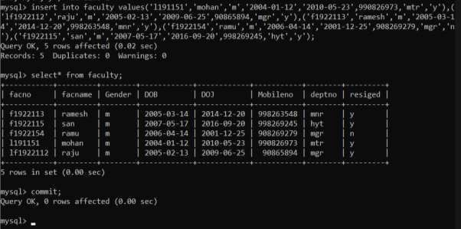

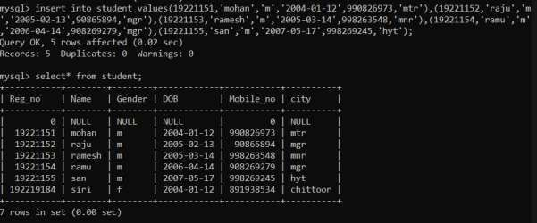

2)

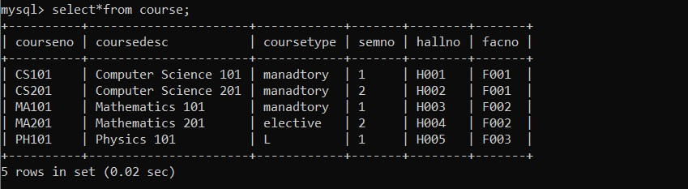
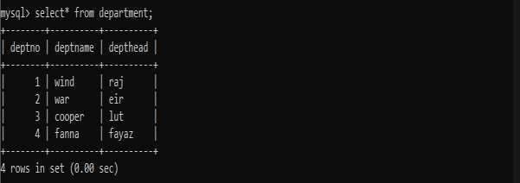

RESULT:
Data Manipulation Language (DML) Commands such as INSERT, SELECT are performed in the five tables.
Ex.No. : 4  Date: | DML Commands with Constraints –UPDATE, DELETE

Aim:
To perform Data Manipulation Language (DML) Commands such as UPDATE, DELETE in the table.

Description:

Data Manipulation Language (DML) statements are used for managing data within schema objects. DML Commands: Update, Delete
  - UPDATE - updates existing data within a table
  - DELETE - deletes all records from a table, the space for the records remain

UPDATE:
UPDATE table_name
SET column1=value, column2=value2,...
WHERE some_column=some_value;

DELETE:
DELETE FROM table_name
WHERE some_column=some_value;

Questions:
- Update the value of student name whose register number is ‘191711342’
- Delete the record in the table FACULTY, who resigned her job.
- Modify the age for the faculty whose name is 'mohan' with a value ‘59’.
- Remove all faculty who are having over 65 years
OUTPUTS:
1)

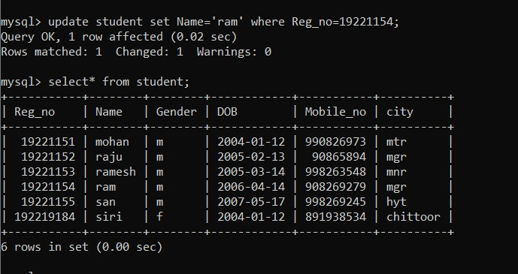

2)

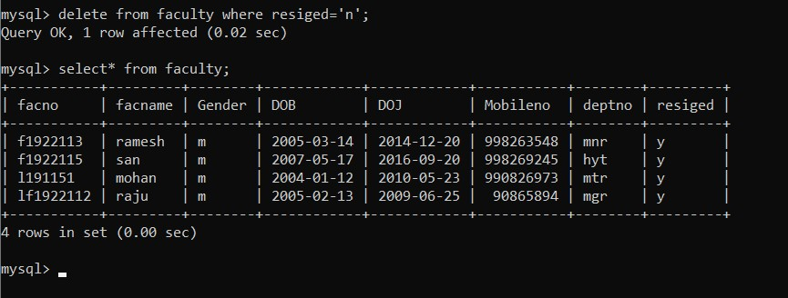

3)
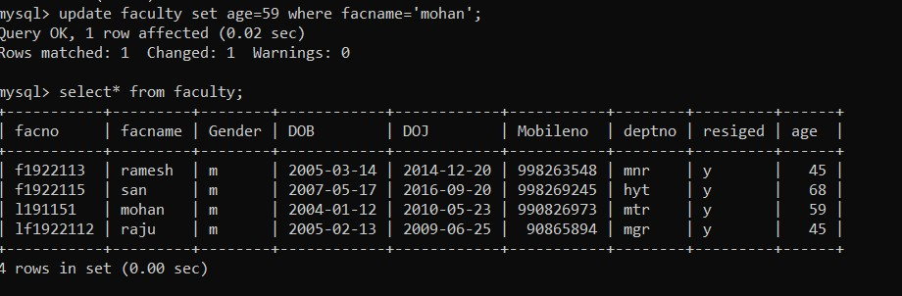
4)

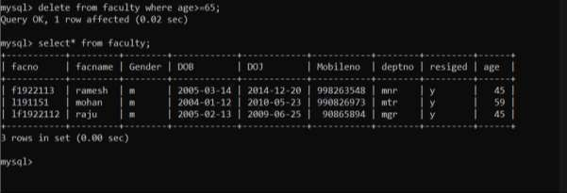

RESULT:
Data Manipulation Language (DML) Commands such as UPDATE, DELETE are performed in the five tables.
Ex. No.: 5  Date: | SELECT with various clause – WHERE, pattern matching

AIM:
To view the records from the tables using SELECT commands with WHERE Clause and Pattern matching.

DESCRIPTION:
The SELECT statement allows you to get the data from tables. A table consists of rows and columns like a spreadsheet. Often, you want to see a subset rows, a subset of columns, or a combination of two. The result of the SELECT statement is called a result set that is a list of rows, each consisting of the same number of columns.

SELECT:
SELECTcolumn_1, column_2, ...
FROMtable_1
[INNER | LEFT |RIGHT] JOIN table_2 ON conditions WHEREconditions

GROUP BY column_1
HAVING group_conditions
ORDER BY column_1
LIMIT offset, length;

The SELECT statement consists of several clauses as explained in the following list:
- SELECT followed by a list of comma-separated columns or an asterisk (*) to indicate that you want to return all columns.
- FROM specifies the table or view where you want to query the data.
- JOIN gets related data from other tables based on specific join conditions. ➢ WHERE clause filters row in the result set.
- GROUP BY clause groups a set of rows into groups and applies aggregate functions on each group.
- HAVING clause filters group based on groups defined by GROUP BY clause.
- ORDER BY clause specifies a list of columns for sorting.
- LIMIT constrains the number of returned rows.
LIKE:
- The LIKE operator is commonly used to select data based on patterns. Using the LIKE operator in the right way is essential to increase the query performance.
- The LIKE operator allows you to select data from a table based on a specified pattern. Therefore, the LIKE operator is often used in the WHERE clause of the SELECT statement.
- MySQL provides two wildcard characters for using with the LIKE operator, the percentage % and underscore _ .
- The percentage ( % ) wildcard allows you to match any string of zero or more characters.
- The underscore ( _ ) wildcard allows you to match any single character.

Questions:

WHERE:
- The student counselor wanted to display the registration number, student name and date of birth for all the students.
- The controller of examinations wanted to list all the female students
- List the Students who registered for the “C001” course.
- Display all faculty details joined before “November 2014”
- Display all the courses not allotted to hall ‘H001’ LIKE:
- List the students whose name ends with the substring “sh”
- Display all students whose name contains the substring “sh”
- Find all the students who are located in cities having “Sal” as substring
- Display the students whose names do not contain six letters.
- Find all the students whose names contains “am”.
OUTPUTS:
1)

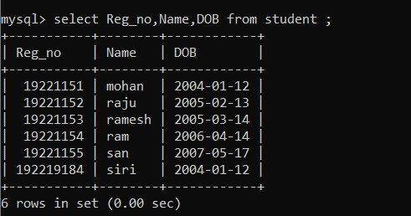
2)
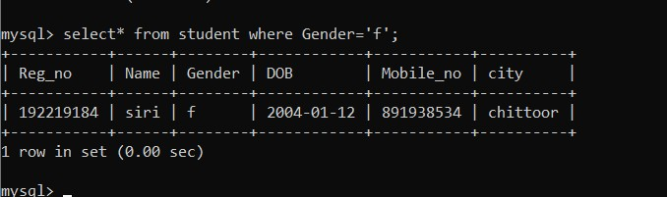
3)
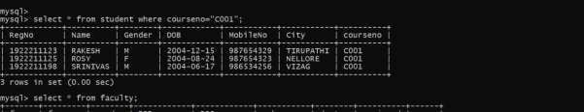
4)
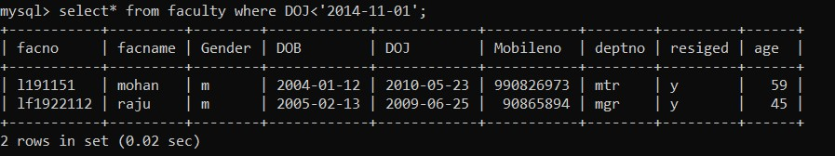
5)

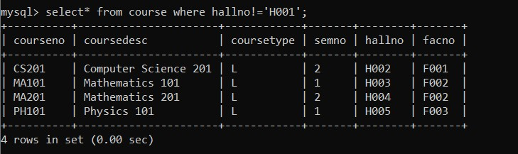
6)
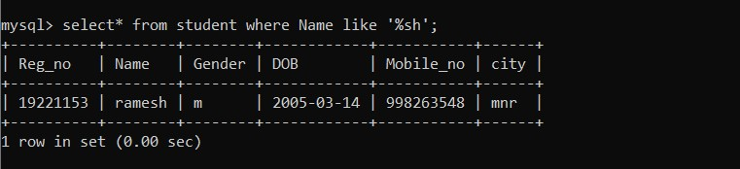

7)
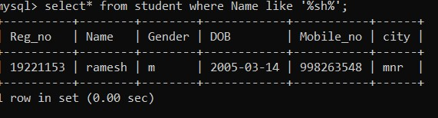
8)
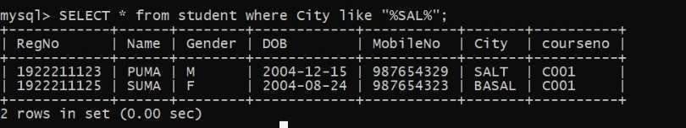
9)
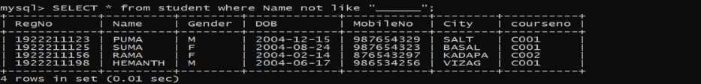
10)

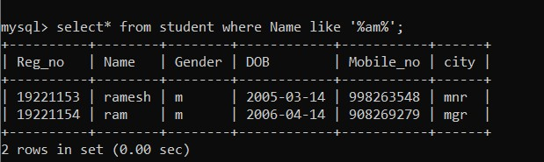

RESULT:

The records from the tables are displayed using SELECT commands with WHERE Clause and Pattern matching.

